ANIMATRONICS FACE: PROF. HARRY MILLWATER

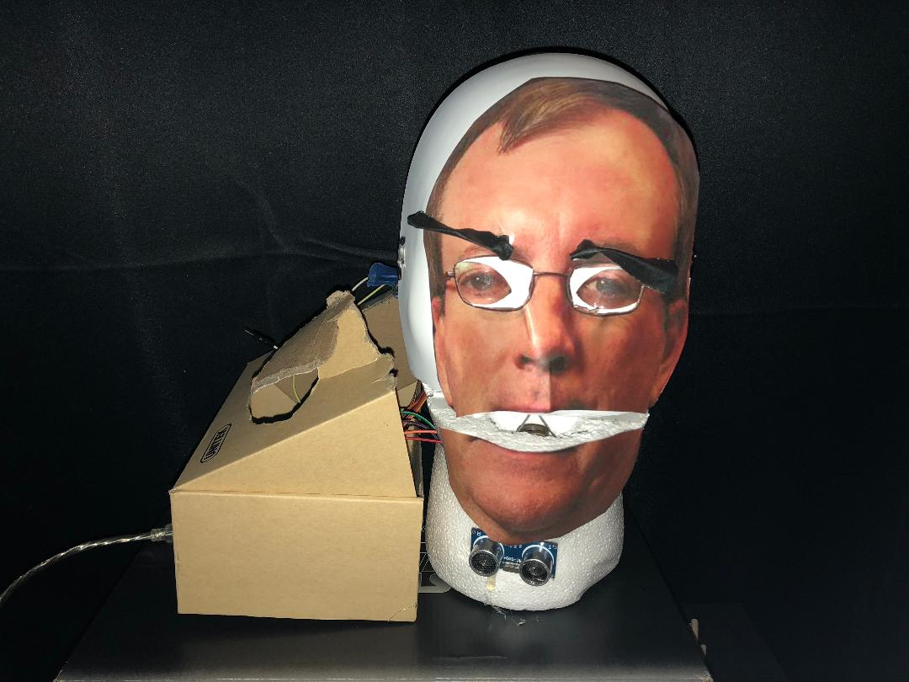

Ty Palowski

Dept. of Mechanical Engineering

San Antonio, TX, USA 78249

typalowski@yahoo.com

Blas Telles Jr

Dept. of Mechanical Engineering

San Antonio, TX, USA 78249

blastellesjr@gmail.com

Submitted as part of project for ME 4543 Mechatronics, Fall 2018

TABLE OF CONTENTS

|  |  |
| --- | --- |
| Section | Page Number |
| Abstract | 3 |
| 1. Literature Review | 5 |
| 2. Supporting Structure | 5 |
| 3. Joints and Motors | 6 |
| 4. Sensors | 7 |
| 5. Programming | 9 |
| 6. Lesson learnt and suggestions | 9 |
| 7. Personnel and Bill of Materials | 9 |
| Appendix A: Code | 12 |

**ABSTRACT**

The purpose of this project was to demonstrate a working understanding of sensors and actuators. To do this, we were tasked with creating an animatronic robot in the likeness of a professor at UTSA. To successfully accomplish this project, we had to be able to operate the project using two sensors which had an unique action for each sensor. To accomplish this, our team created a robot out of a foam head, wooden dowels, ping pong balls, some mechanical nuts, hanging wire, an ultrasonic sensor, three stepper motors, and an Arduino MEGA. Using these materials, we successfully created a robot in the likeness of Dr. Harry Millwater.

**Section 1: Literature review**

The first animatronic face that was researched was a face created by hackintoshlover12 on instructables.com [1]. For this design, he used 11 mini servo motors, 2 normal servo motors, 1 Arduino Uno/Mega, 1 Arduino sensor shield v5.0, and 1 ultrasonic sensor. The servo motors were used for the movement of the eyelids, eyes, mouth, and other facial features that required movement. The Arduino was used to run the program which controlled the robot. The ultrasonic sensor was used to activate Fritz from a distance by walking in front of him.

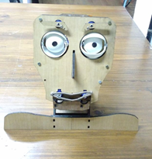

Figure 1: FRITZ

The second animatronic face that was researched was a face by knife141 on instructables.com [2]. This design used various servos, a servo controller (MiniSSCII), a single-board computer (RAPU), compact flash card (used in the RAPU), and a micro switch. The servos were used in a similar manner to the first design, which used them to control the head’s movement and facial features. The servo controller is the middle man between the servos and the RAPU. The servo controller takes the signals from the RAPU and turn them into motion. The RAPU was used to store the programs to control the head. The micro switch was used to control a light that was mounted on the head.

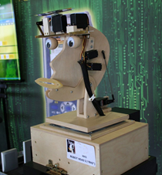

Figure 2: Robot Head 2

The third animatronic face that was researched was a face by gtoombs on instructables.com [3]. This face was created by a former student at the University of Texas at San Antonio (UTSA) as a special project for an independent study. This design used 5 servo motors, 10 micro servos, 1 large servo, and an Arduino Mega. These servo motors were used to control the facial features like the other two designs. The Arduino was used to store the code and operate the robot.

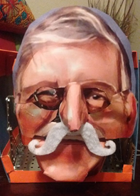

Figure 3: RomoBOT

**Section 2: Brainstorming (initial planning)**

I would like this animatronic figure to do at least 2 things: 1) have the mouth and audio synchronized to give the illusion that the head is speaking and 2) be able to trigger the audio greeting without a button. To do this, I would require a hinge at the jaw to be moved with a servo motor which will be triggered using an ultrasonic sensor. The head will be made of wooden dials and a foam head. I believe that using this will allow the head to be sturdy and strong enough to contain the components needed for movement. Using the foam head, I will have a good base to allow for the face to be pasted on to. I plan to use an audio shield for an Arduino to store and play the audio file. The mouth and audio will be synchronized by timing the syllables of the phrase collected from Mr. Millwater. I plan to collect a phrase that Mr. Millwater is known for or a phrase that has a special meaning to him. The head will be powered using an external battery. The battery can be a 9V battery or a rechargeable lithium ion battery.

**Section 3: Supporting structure**

The supporting structure consisted of an off the shelf solid foam head as depicted in Figure 4. Using this allowed us to not worry about creating a supporting structure. In order to make the the head talk, the face of the foam head had to be cut off. Once the face was off, the head could then be hollowed out. With the head hollowed out, a structure that held the eyes could then be built.

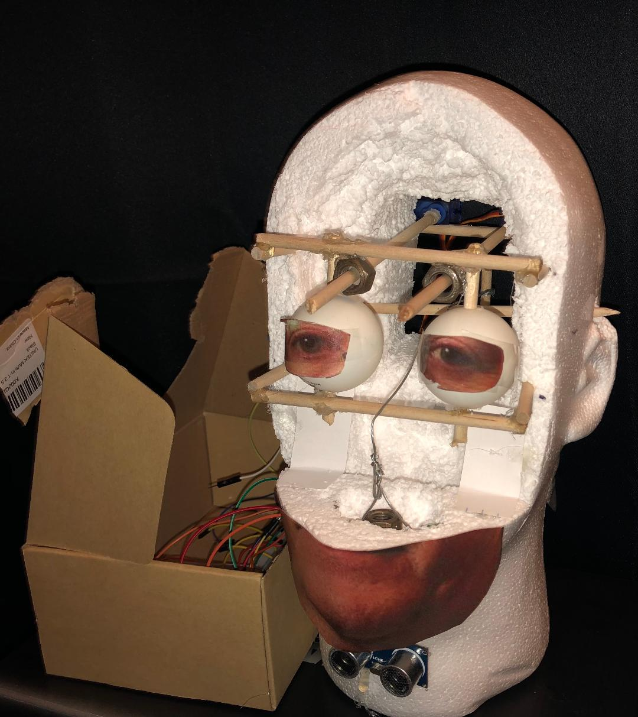

Figure 4: Structure of head (Front).

The structure that held the eyes was made out of wooden dowels that were pushed through the head. Along with that structure, a single wooden dowel was used as a pulley which hanging wire was placed over to allow the jaw to controlled with a servo motor. The jaw was cut from the face that was cut off from the foam head and was attached to the hollowed head by hinges made from index cards. Since the face from the foam head had to be cut to extract the jaw, the head above the jaw was not useful to us. To complete the face, the top portion of the face was constructed from a mask that was cut to match the size of the jaw. Two dowels ran from the back of the head to the forehead. These dowels were centered over the eye. A hole over the eye had to be made to allow the dowel to protrude. These dowels were used to operate the eyebrows of the project.

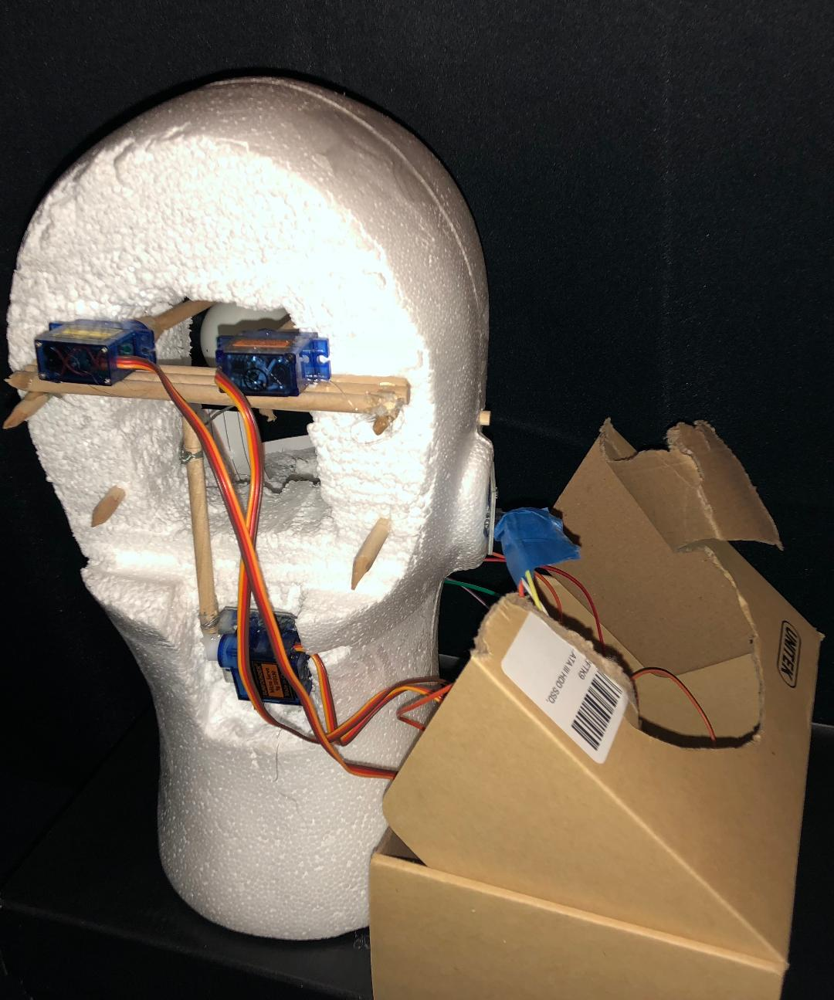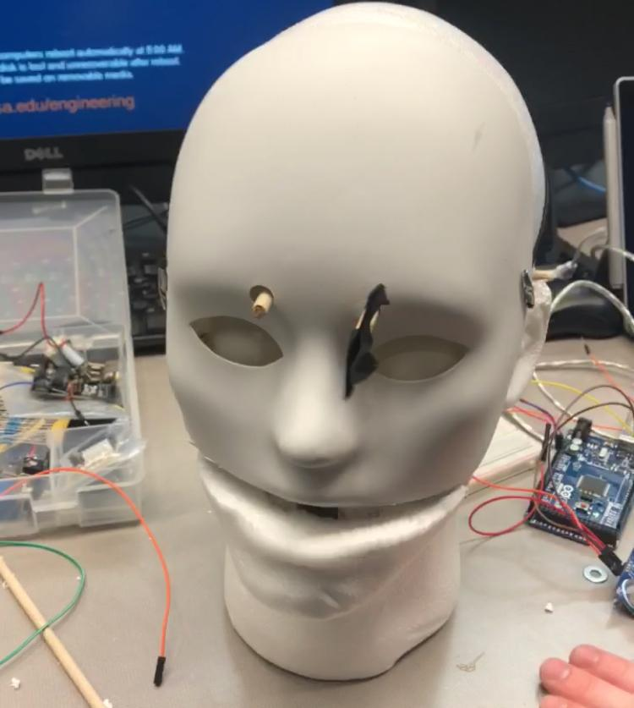

Figure 5: Structure of head (back). Figure 6: Head with mask cover.

A motor for each eyebrow was used and placed at the back of the head. The dowels were supported by two nuts that were glued to an box made from the dowels in the back of the head.

**Section 4: Joints and motors**

The joint of the mouth was pretty simple to create. The joint was created from strips of index card and glued to the hollowed head. To make sure that the jaw would hinge the way we planned, a small pocket had to be made in the neck to allow the mouth to fall into a speaking position. To control the mouth, a stepper motor was used. This motor was used because it would allow us to lower and raise the mouth between an optimal angle to imitate speaking. The next thing that needed to be controlled was the motion for the eyebrows. We used a motor for each eyebrows. A stepper motor was used to allow us to spin the eyebrows a predetermined amount of revolutions.  
  
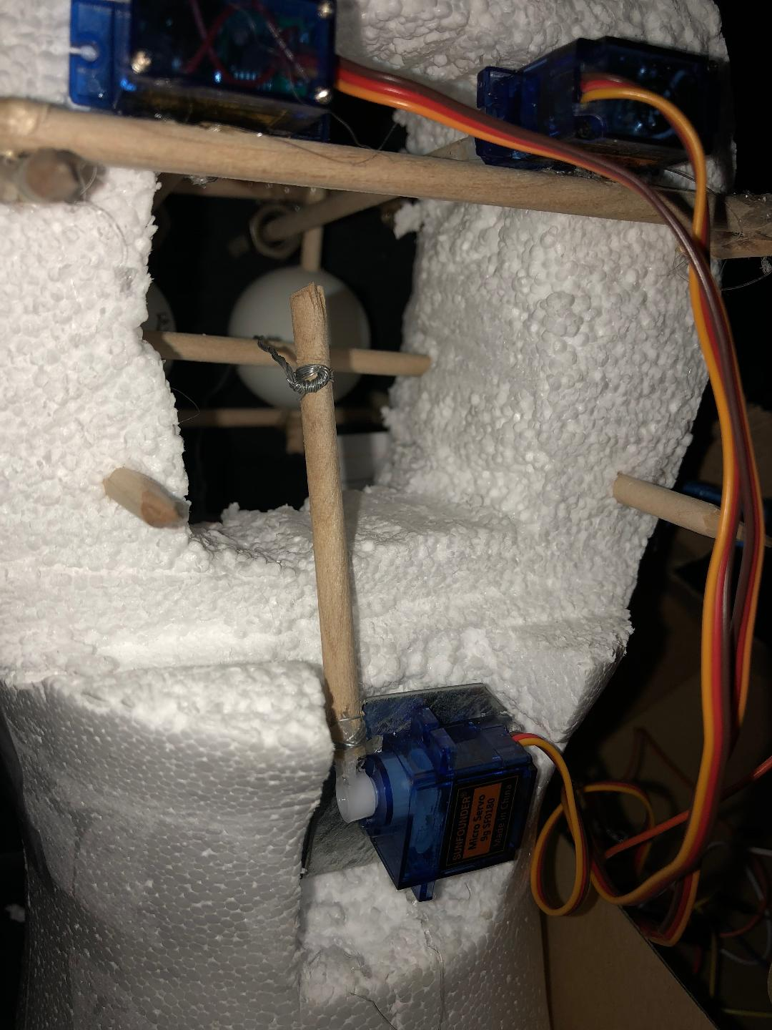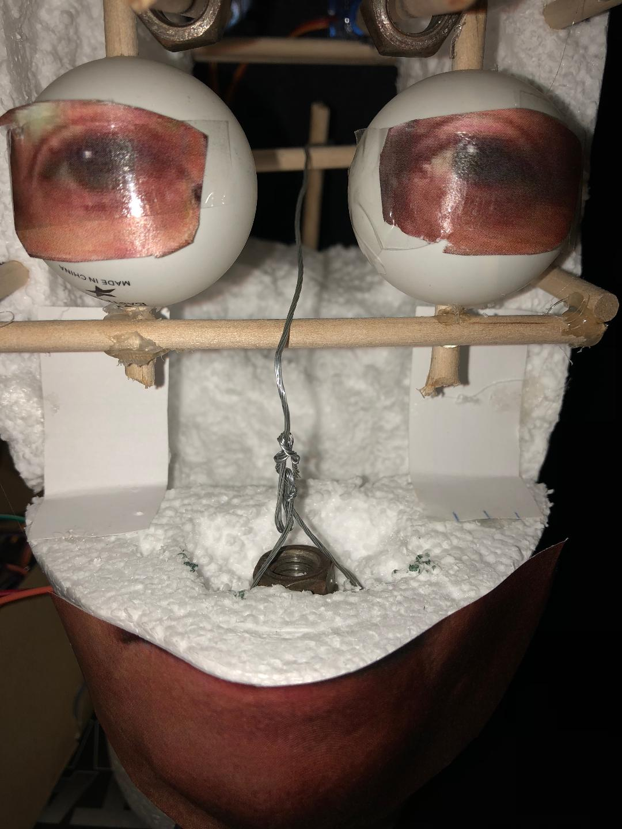

Figure 7: Mouth armature. Figure 8: Continuation of mouth mechanism

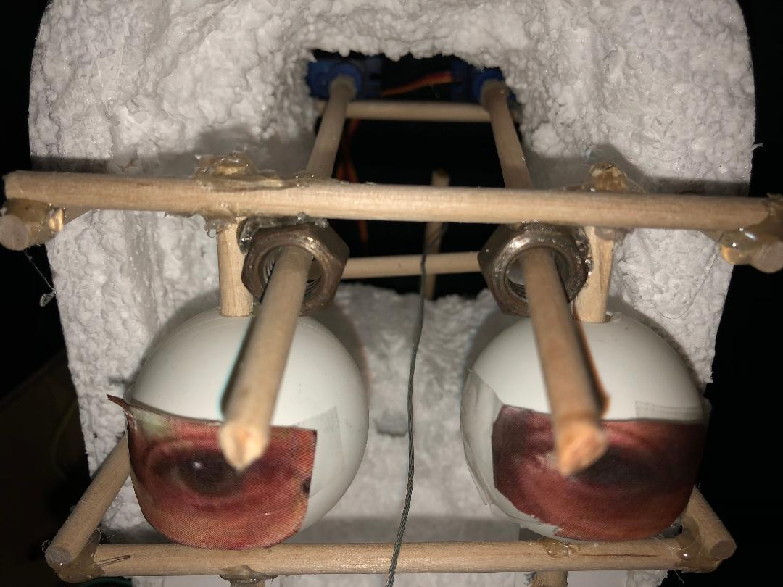

Figure 9: Nuts used as bearings to hold eyebrow servo shaft extensions.

**Section 5: Sensors**

This project included two sensors. The two sensors used was an ultrasonic sensor and a touch sensor. The ultrasonic sensor was used to control the two servo motors which rotated the head’s eyebrows. When an object came within 20cm of the ultrasonic sensor, the servo motors were to rotate to a specific angle and back with a minimal delay. Ultrasonic sensors work by emitting sound waves at a frequency too high for humans to hear. They then wait for the sound to be reflected back, calculating distance based on the time required. This is similar to how radar measures the time it takes a radio wave to return after hitting an object.

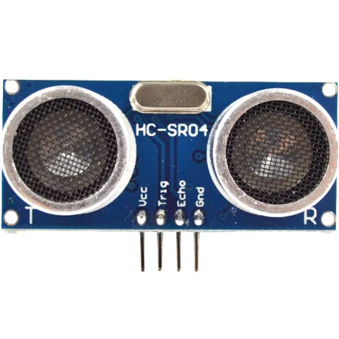

Figure 4: Ultrasonic Sensor used in project.

The Second sensor used was a capacitive touch sensor affixed to the head’s ear. This was to comically make the action of activating the mouth of the animatronic activate when you stuck your finger in its ear.

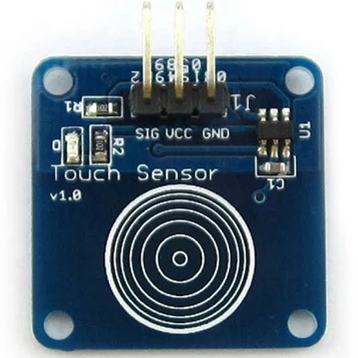

Figure 5: Capacitive touch Sensor used in project.

The touch sensor, as previously stated, controlled the single servo motor attached through a pulley system that opened and closed the head’s mouth. The capacitive sensor works by measuring changes in an electrical property called capacitance. Capacitance describes how two conductive objects with a space between them respond to a voltage difference applied to them.

**Section 6: Programming for interaction**

The main purpose of the program was to make simple motions from basic inputs, be it from the ultrasonic sensor or from the touch sensor. The original concept of the code was to make it as simple as possible in order to both fit the time constraints placed upon the group members due to work and class conflicts. The code utilized the extensive library on the *Github* website that also contained the libraries such as <servo.h> used in the code. It was up to the students to take the framework example codes and adjust them accordingly to fit the applications required in the project. The end result was a code that allowed for comical human interaction in the presentation covered by local news stations and an all around pleased professor/teaching assistant.

**Section 7: Lessons learnt and suggestions**

1. How to use sensors to initiate commands
   1. Make sure to use all resources when it comes to programming to save time. Arduino is open-source and there are copious amounts of tutorials along with example code on YouTube and across maker-based websites.
2. How to turn imagination into reality
   1. When starting this project, the problem of creating an animatronic head was given to us. To solve this, we had to use our imagination to come up with a solution. Once that solution was dreamt up, it then had conveyed between teammates to come up with the best solution. What followed was the gathering of materials and turning our best solution into a reality.
3. How to diagnose problems and find a solution

**Section 8: Personnel and bill of materials**

**(a) Personnel**

|  |  |  |
| --- | --- | --- |
| Task | Main Personnel | Secondary personnel |
| Structure/Chassis Design | Blas Telles Jr | Ty Palowski |
| Creating Joints and Motor Interfacing | Blas Telles Jr | Ty Palowski |
| Integrating/Interfacing Sensors | Ty Palowski | Blas Telles Jr |
| Overall Programming and Integration | Ty Palowski | Blas Telles Jr |

**(b) Bill of materials**

|  |  |  |  |  |  |
| --- | --- | --- | --- | --- | --- |
| No. | Description | Website/comment | Qty. | Unit $ | Total $ |
| 1 | Arduino MEGA 2560 | Provided | 1 | - | - |
| 2 | Small servo motor | Only one needed purchase, others owned | 3 | 5.95 | 5.95 |
| 3 | Wooden Dowels |  | 1 | 3.99 | 3.99 |
| 4 | Foam Head |  | 1 | 7.99 | 7.99 |
| 5 | Plastic Mask |  | 1 | 2.99 | 2.99 |
| 6 | Metal Nuts | Spare Nuts (No Cost) | 2 | - | - |
| 7 | Touch Sensor |  | 1 | 2.49 | 2.49 |
| Total | |  |  |  | 30.36 |

The total price for this project excluding the Arduino MEGA, Metal Nuts, and two of the Servos was $30.36.

**References**

# [1] Animatronics Face of UTSA's President, Dr. Ricardo Romo, <https://youtu.be/xkze1_hnam0>

# [2] ROMOBOT - ANIMATRONIC FACE ROBOT

# <https://www.instructables.com/id/RomoBOT-Animatronic-Face-Robot/>

**Appendix A: Code   
